DIS-EUR-Vinca figurine-5700-4500 B.C.E.-terracotta-male

Vinca figurine, Central Europe-5700-4500 B.C.E. Terracotta in fine condition.

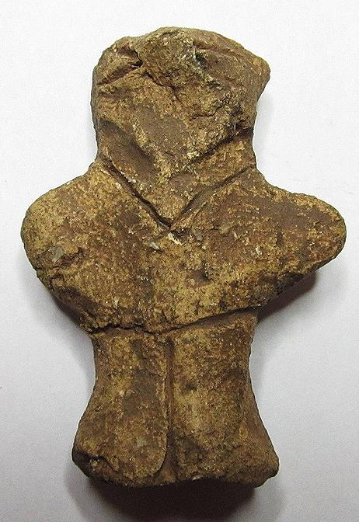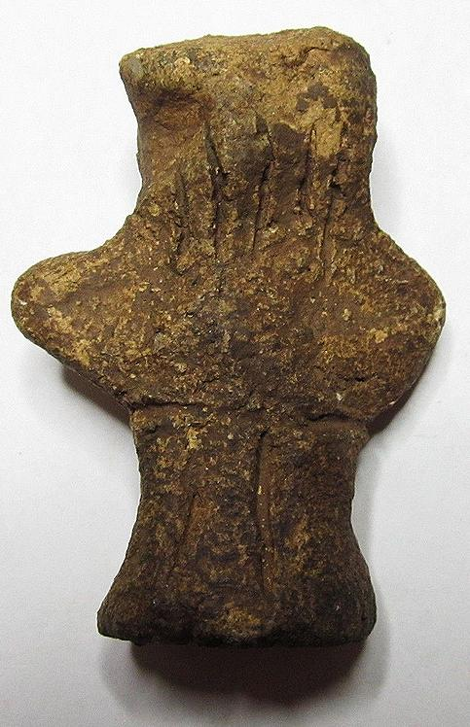 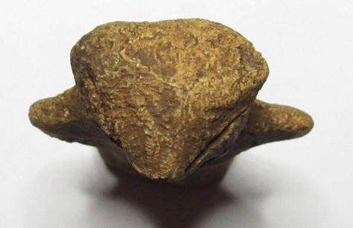

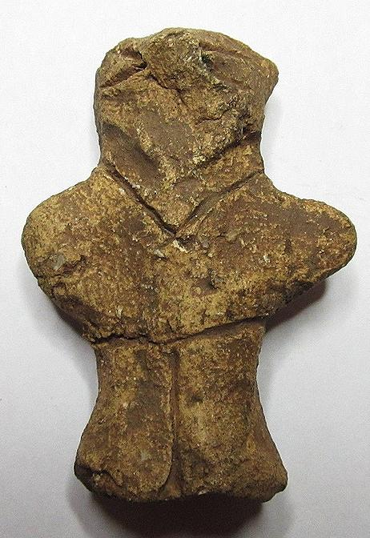 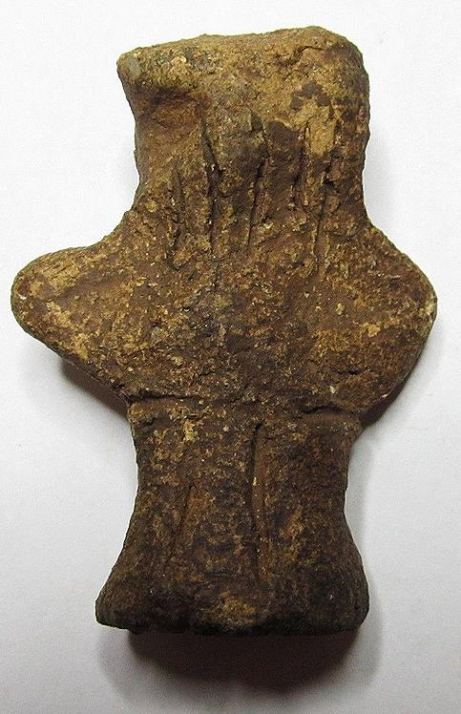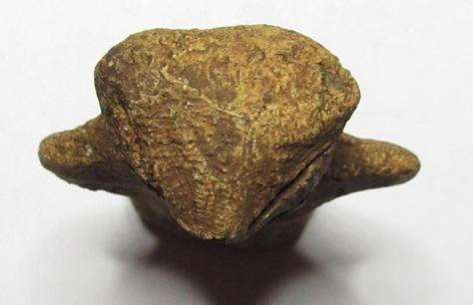

#### [Ancient Neolithic Vinca Culture Idol Goddess ~ old collection!](http://www.ebay.com/itm/281906133218)

|  |  |
| --- | --- |
| Item price | $330.00 |
| Quantity | 1 |
| Item number | 281906133218 |
| Shipping service | Standard Shipping from outside US |

Ralph J Coffman Jr

149 Atlantic Ave

Swampscott MA 01907-2427

United States

## Order total

|  |  |
| --- | --- |
| Subtotal | $782.50 |
| Shipping | $32.99 |

**Total**

$815.49

Order placed on

Monday, Jan 18, 2016

Payment method

PayPal

Payment date

Monday, Jan 18, 2016